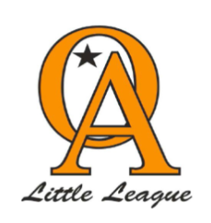
Orcutt American Little League
Tee-Ball 2024 League Rules

- On all Fields the Home team will set up the field and the visiting team will breakdown and clean up the field. This is to include the emptying of the trash cans for their field for that day.

- Every player on a T-Ball team will participate for a minimum of 50% of the game and a continuous batting order will be used.
  - Note: T-Ball divisions shall use continuous batting order that includes all players on the roster present for the game batting in order. Each player is required to bat in his/her respective spots in the batting order; however, a player may be entered defensively into the game any time provided he/she meets the requirements of mandatory play.

- Players cannot sit on the bench for more than 1 inning in a row.

- Tee Ball: No more than 2 bases on any hit, Batter or Runner.

- No advancing on pass balls or overthrows to the pitcher.

- No stealing allowed.

- Three inning limit in Tee-Ball
- Only Managers speak with other Managers.
- USA Bats ONLY
- 3 inning limit or 1 hour and 15 game time

